Name:
Class ID:
Class Hour:
Chapter 10
Mobile Banking, Checks, and Reconciliation

Recap:
Benefits of a Checking Account:

Banking Fees:
Overdraft fees are the largest fee banks charge consumers. What is the average fee charged by banks? . In addition to these fees, there are several others you should be know about and follow. When you open an account at a Bank. Ask for a list of
. Or when you open the account, it will be a part of the .

Bank Fee Terms:
Bank Maintenance Fees:
ATM Fees:
NSF Fees See Overdraft Fees
Minimum Balance/Deposit Fees
Statement Fees
Deposit Item Returned
Stop Payment Fees

How to Deposit Money

Mobile Banking Alerts
Definition | Types
Unusual Activity Alert:

Low Balance Alert:

Mobile Deposit Alert:

Other Recommended Alerts:

Travel Notice:

Checking Account Terms:
Check:
Deposit/Withdrawal Slips:
Endorsement:
Check Register:

Deposit Slip:
- Check #1345 for $50, Check 1986 for $100 and you want to keep $25.00 cash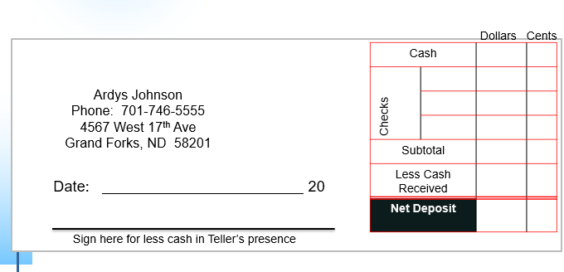

Parts of A Check:
-Circle the Routing Number.
-Put a Box Around the Account Number
-Put an X on the Check Number
The person writing the check is called the or the payer. The person receiving the check is called the . When writing a check, the amount of the check is more binding than the numeric number because the numeric can be hard to read. The memo field is used like a . It just tells you what you spent the money on.
When writing the written amount, write the change as a fraction of over (there are 100 pennies in a dollar so 12/100 as shown below means 12 cents).

Check Endorsements
Blank Endorsement:
Special Endorsement:
Restrictive Endorsement:
Complete from the notes slides shown by your instructor:
Blank Special:
Restrictive

Restrictive you deposit the physical Restrictive for Mobile banking
check at the bank

